Dis-Eur-Greece-Trireme Ship

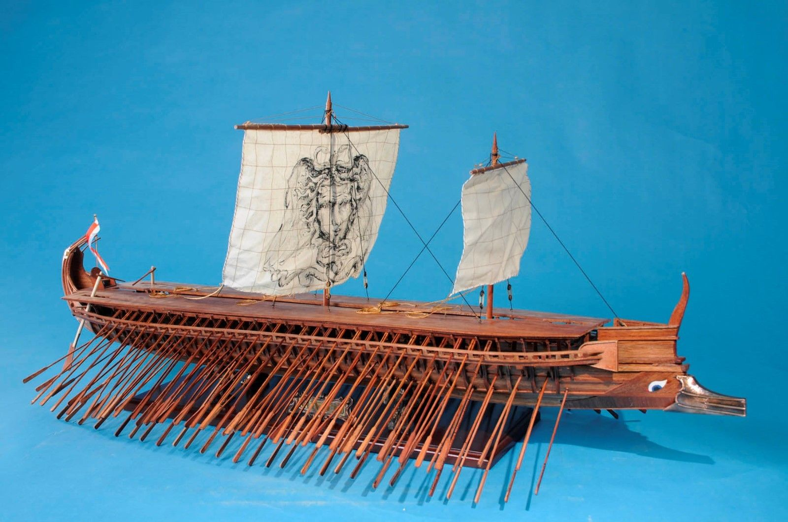

I found a photo of the completed model online so you can see what it will look like, but it has never been out of the crate and I'm not removing it so it ships safely. Sorry for the photos shot through the wood frame but you can see it is a quality item. It looks like it is plank on hull construction, not a solid wood hull. Also note the metal-covered ramming bow in the front of the ship. Still tied down, the model is almost complete and requires that the sails be raised and the three rows of oars inserted in the hull (see instruction sheet). Also in boxes and tied down in the crate are what I'm assuming is a stand and stanchions to mount the model on. There are a few small pieces that need repair -- the small wooden pieces probably came loose in transit and all fit on the side of the hull, one is a tiller for the large steering oar on the side, and the flag staff split but all the pieces are there. All these fixes require is a small amount of glue and a clamp.